Contact: Tammy Sherbert
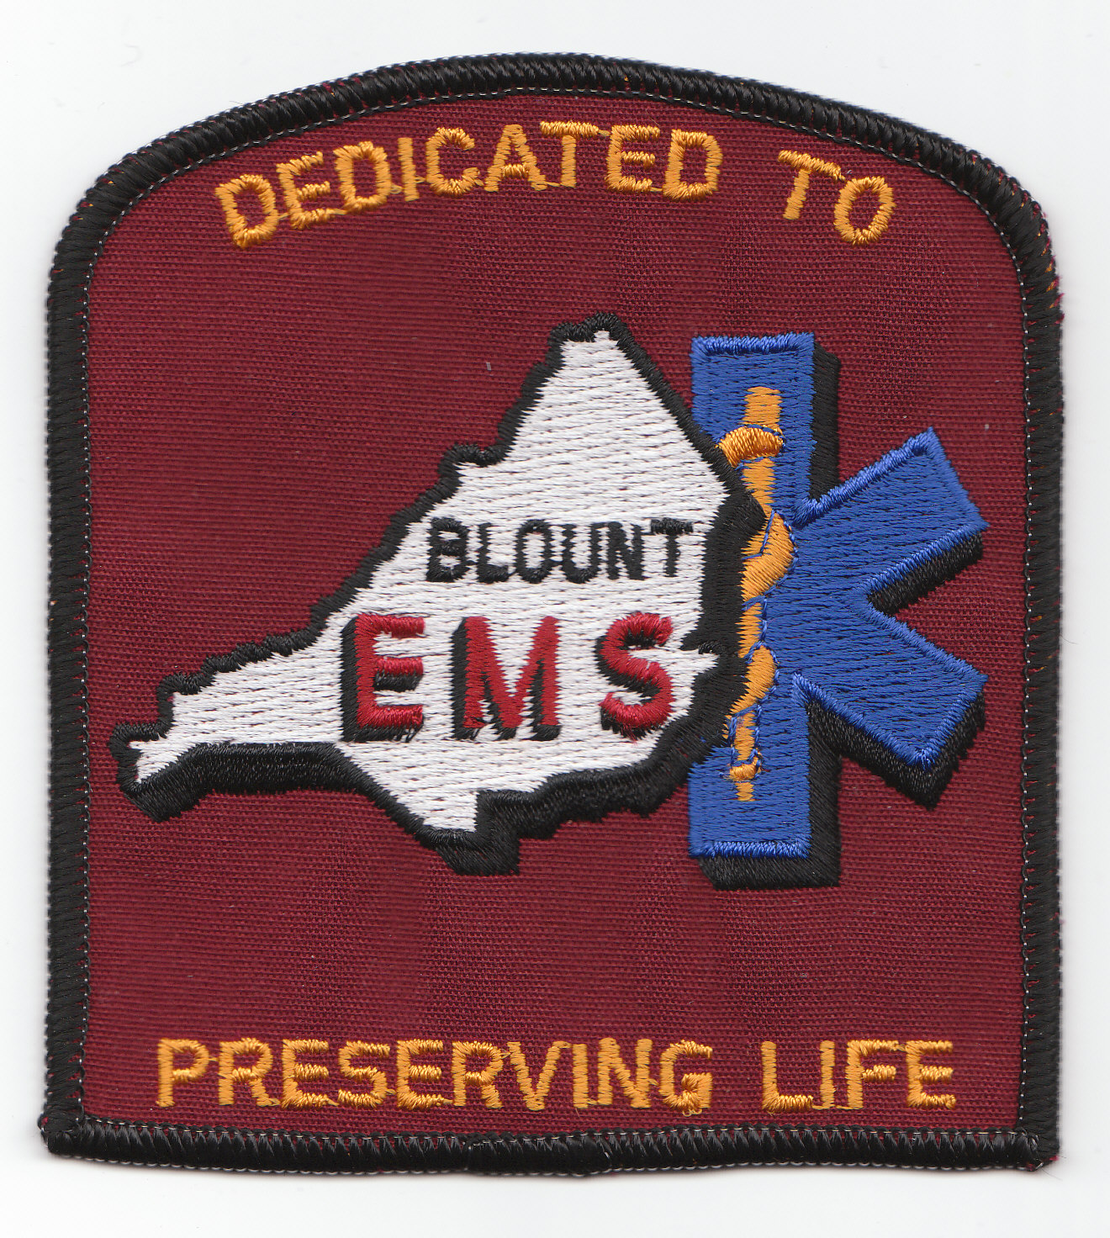
Phone number: (205) 625-4567
Email: tammyblountem@otelco.net
Address: 375 Valley Rd
Oneonta, AL 35121

Press Release
BLOUNT EMS DONATES AED (AUTOMATED EXTERNAL DEFIBRILLATOR) TO BLOUNT COUNTY COURTHOUSE
Oneonta, AL., March 15, 2012: Paramedics and EMTs working for Blount EMS, the ambulance provider throughout Blount County, are well aware that a cardiac arrest can strike anywhere at any time. In these cases, a patient’s best chance for survival is to activate the EMS system by calling “911” and immediately starting CPR. A cardiac arrest victims chances for survival can go up as high as 30 percent if an AED (automated external defibrillator) is used within 8 minutes of a sudden cardiac event. If not used, the survival rate hovers around 4 percent.

Working with the Blount County Administrator, Ralph Mitchell, it was decided to donate an AED to the County to be placed in the courthouse. Says, Mr. Mitchell, “Hundreds of citizens are in and out of the County Courthouse every week. It only made sense that this would be an ideal location for the AED. We are extremely appreciative of the generosity of Blount EMS to provide this life-saving device and training our personnel to use it.”

The AED is a Powerheart AED G3 Plus made by Cardiac Science. The device uses intuitive voice prompts to guide the rescuer confidently and easily through the rescue process. The new detailed instructions for CPR include a metronome to assist with frequency of compression. The device will perform self-tests to ensure that the critical components such as pads, battery and internal circuitry are always in working order and validate reliability.

According to Tammy Sherbert, Manager for Blount EMS, “If a person suddenly experiences a cardiac arrest and an AED is on hand, a bystander or anyone trained in the use of an AED can grab it and easily connect it to the person’s chest following the simple directions provided. The machine does all the work and reads the person’s heart rhythm, possibly saving their life.”

Blount EMS plans to offer training to the Blount County Courthouse Staff on how to properly use the AED. This will enable the staff to recognize the signs of a sudden cardiac event and respond with an AED and provide CPR, until the Paramedics arrive.

About Blount EMS
Blount EMS is a subsidiary of NorthStar EMS (NEMS) which is Alabama’s largest private provider of EMS medical care and transportation services, serving ten counties. Blount EMS has been serving the citizens of Blount County since April 15, 1995. With its Team of EMT and Paramedics, Blount EMS stands ready to provide emergency and nonemergency care and transportation services.

Website: www.northstar-ems.com

For Release: 11 a.m. CST, March 15, 2012

