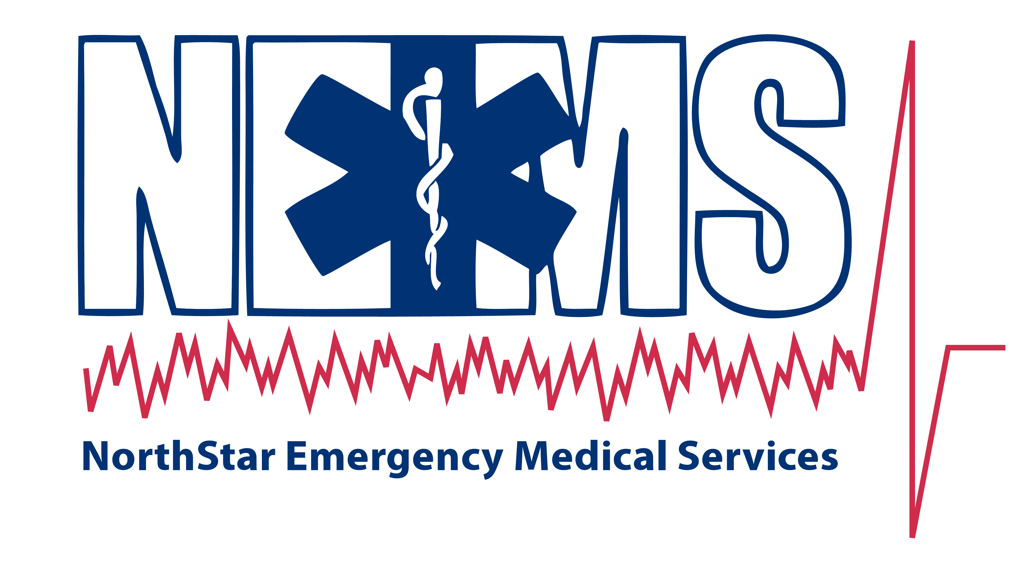
For Immediate Release: July 28, 2026
Press Contact: Brent Dierking, 205.337.4243

NorthStar EMS Offers Firework Safety Tips for Fourth of July Festivities
Tuscaloosa, AL; The 4th of July and summer season bring celebrations with family and friends, barbecues, picnics and fireworks; but while the summer holiday is lots of fun, it also can be hazardous.
NorthStar EMS is offering the following series of safety tips to help ensure that Tuscaloosa residents make the most out of their holiday without running into potential hazards.
Firework Safety
It is estimated that in 2009 about 8,800 people were treated in hospital emergency rooms for injuries associated with fireworks. More than half the injuries were burns and most of the injuries involved the head (including face, eyes and ears) hands, fingers and legs. Children and young adults under the age of 20 accounted for more than 50 percent of the estimated injuries. Fireworks should be used only with extreme caution. Older children should be closely supervised, and younger children should not be allowed to play with fireworks, including sparklers.

There is still a risk of injury with the use of legal sparklers. When lit, some sparklers can reach temperatures between 1,300 and 1,800 degrees - at least 200 degrees hotter than a standard butane lighter.

NorthStar EMS presents the following firework safety tips as stated by the US Consumer Product Safety Commission:

- Do not allow young children to play with fire-works under any circumstances. Sparklers, consid-ered by many the ideal "safe" firework for the young, burn at very high temperatures and can easily ignite clothing. Children cannot understand the danger involved and cannot act appropriately in case of emergency.
- Older children should only be permitted to use fireworks under close adult supervision. Do not allow any running or horseplay.
- Light fireworks outdoors in a clear area away from houses, dry leaves or grass and other flammable materials.
- Keep a bucket of water nearby for emergencies and for pouring on fireworks that fail to ignite or explode.
- Do not try to relight or handle malfunctioning fireworks. Douse and soak them with water and throw them away.
- Be sure other people are out of range before lighting fireworks.
- Never ignite fireworks in a container, especially a glass or metal container.
- Keep unused fireworks away from firing areas.
- Store fireworks in a dry, cool place. Check instructions for special storage directions.
- Observe local laws.
- Never have any portion of your body directly over a firework while lighting.
- Do not experiment with homemade fireworks.
Of course if you need us, NorthStar EMS paramedics are there for you and ready and equipped to respond should you need their help. The team at NorthStar EMS wishes every citizen a happy and safe summer holiday season!

